**6th Grade General Music**

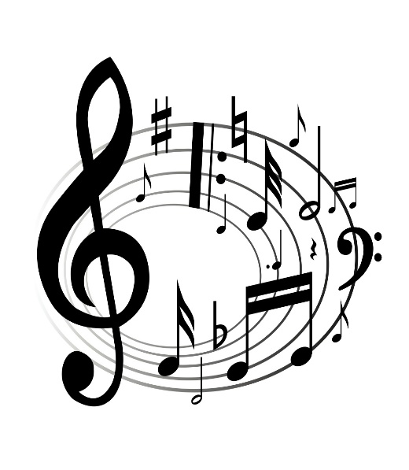

[This Photo](http://informationaction.blogspot.com/2012_12_01_archive.html) by Unknown Author is licensed under [CC BY-SA](https://creativecommons.org/licenses/by-sa/4.0/)

**Periods 1, 6, & 7**

**2017-2018 Eisenhower Middle School**

*Eisenhower Middle School Choral Music & General Music*

Teacher: Mrs. Plunkett

[Eplunkett@everettsd.org](mailto:Eplunkett@everettsd.org) 425-385-7500

https://www.everettsd.org/Domain/3215

**KEEP THIS AS PAGE #1 IN YOUR GENERAL MUSIC FOLDER**

**“We have read and understand the following General Music syllabus and expectations:”**

**_______________________/____________ ____________________________/____________**

**Parent or Guardian Signature/Date Student Signature/Date**

**PARENT E-MAIL__________________________________________________________________________**

COURSE DESCRIPTION

* This class will provide a worthwhile musical experience for students, regardless of individual skill or talent level.
* The semester will be divided between hands-on learning through drumming, and learning how music rooted in African rhythms made its way to America and evolved into Ragtime, Blues, Jazz, and eventually Rock & Roll.
* Objectives for World Music Drumming curriculum may be found by following this link:

<http://www.worldmusicdrumming.com/wmd-objectives/>

WHAT YOU’LL NEED and WHAT IS PROVIDED:

* You will need a pencil and eraser. “Something to write with”
* I will provide a music folder compliments of our local music vendor.
* Folders will be stored in the folder-slot wall in our classroom.
* Each student will be assigned a folder number and will have their own slot.
* Instruments will be provided for in-class participation.

DESCRIPTION OF STANDARDS:

* Use of the Washington State Arts Standards in Music will be the basis of lessons and assessments. The Washington standards follow the National Core Arts Standards (NCAS) using the sequence of “Create-Perform-Respond-Connect”, as a way for students to learn and apply their understandings to familiar and unfamiliar situations. The state standards can be accessed at <http://www.k12.wa.us/Arts/Standards/2017/MusicStandards.pdf>
* World Music Drumming as well as History of Rock and Roll music have these standards threaded throughout the curriculum and objectives.

GRADING SCALE:

50% Student demonstrates instruction in class, contributes to discussions, and remains respectful.

30% Written assignments

20% Quizzes and Tests

* Late assignments will be accepted if the student shows a process of refining their work and improving over time, however, please do not wait to turn all late work in during the last weeks of the semester. (as in a “cram session”). You will know the final date that I will accept late work.
* The pace of the class may vary considerably according to several factors including students’ musical readiness, students’ physical coordination, and **students’ readiness to work as a team**
* Assessments include both student’s physical demonstration of music skills and written work.
* Written assignments, quizzes, and tests will include expectations and grading rubric as assigned.

Each student will begin the semester with 200 points. Points may be deducted if a student has not met the described expectations in this table:

Daily Expectations and Student Demonstration of Music Technique Point Chart

|  |  |
| --- | --- |
| 5-point deduction if not met | Student demonstrates instruction in class, **contributes** to discussions, and remains **respectful** of people, music, and cultures studied. |
| 5-point deduction if not met | Student understands importance of **entering and exiting** class respectfully. Student can demonstrate positive classroom behavior which benefits the total classroom experience of teamwork and music-making. |
|  | If the above is not met while in class or at a performance, a student may have up to 10 points deducted from their Daily Expectation grade each day. (Or, student may stay on task and keep all his points). |

|  |  |
| --- | --- |
| “Rehearsal & Performance Technique” | Grade Description |
| **180-200 Points**  (90-100%) | Student demonstrates skills at a high level. Student always contributes to class. Always brings materials needed to class. Easily follows directions or tries to follow directions. |
| **160-179 Points**  80-89% | Student almost always follows above description |
| **140-159 Points**  70-79% | Student is not consistent with above description, or shows reluctance to try and follow description |
| **Less than 140**  69% and below | Student is not interested in the work required in improving as a member of the vocal group |

­­­­

A 93-100%

A- 90-92%

B+ 87-89%

B 83-86%

B- 80-82%

C+ 77-79%

C 73-76%

C- 70-72%

D+ 67-69%

D 63-66%

D- 60-62%

F below 60%

EXPETATIONS:

* As you enter the classroom, you will immediately sit in a student chair with something to write with.
* Your **CELL PHONE** will remain in your locker and not in our class. Any communication with parents, family, or friends can go through the school office if an emergency.
* Use the bathroom or get water BETWEEN classes only, NOT DURING class.
* If you have a bathroom emergency or become ill, let me know. Bring your school planner for me to sign out.
* If you are late, bring a hall pass written inside your planner. The tardy will be excused.
* Please do not play instruments until they are assigned daily.
* NO GUM OR FOOD in class. It makes instruments sticky and smells later. (yuk)
* Sharpen your pencil BEFORE class begins. Please ask if you need to sharpen it once class begins.
* Throwing objects is not allowed unless part of the lesson.

CONSEQUENCES of MISBEHAVIOR:

1. Gentle verbal warning
2. One-on one discussion
3. I will contact your parent or guardian
4. I will contact the office for further discussion